**Final Cloud Engineering Assignment: Multi-Cloud Production-Ready Infrastructure**

**Title:** Designing & Deploying a Scalable Multi-Cloud Infrastructure  
 **Level:** Advanced (Final Project)  
 **Course:** Cloud Engineering  
  
 **Objective:** The goal of this assignment is to design, provision, and deploy a **highly available, secure, and scalable infrastructure** using Terraform, Kubernetes, and CI/CD pipelines. You will implement **multi-cloud deployment** (AWS & GCP), integrate monitoring tools, and ensure security best practices.

**TASK BREAKDOWN**

**Task 1: Infrastructure as Code with Terraform**

**Objective:** Set up a multi-cloud network architecture.

**Steps:** 1️ **Provision AWS Resources:**

* **VPC with public/private subnets**
* **RDS (PostgreSQL) in a private subnet**
* **IAM roles & policies** (least privilege)
* **EKS cluster for Kubernetes**

2️ **Provision GCP Resources:**

* **VPC with peering to AWS VPC**
* **GKE (Google Kubernetes Engine) cluster**

3️ **Create Terraform Modules:**

* **VPC module** (used for both AWS & GCP)
* **Kubernetes module** (used for both EKS & GKE)
* **Security module** (IAM roles, firewall rules, encryption)
* **Deliverables:**- Terraform repo (main.tf, modules/, variables.tf, outputs.tf)  
   - Screenshots of Terraform apply and cloud resources  
   **- Architecture diagram**
* 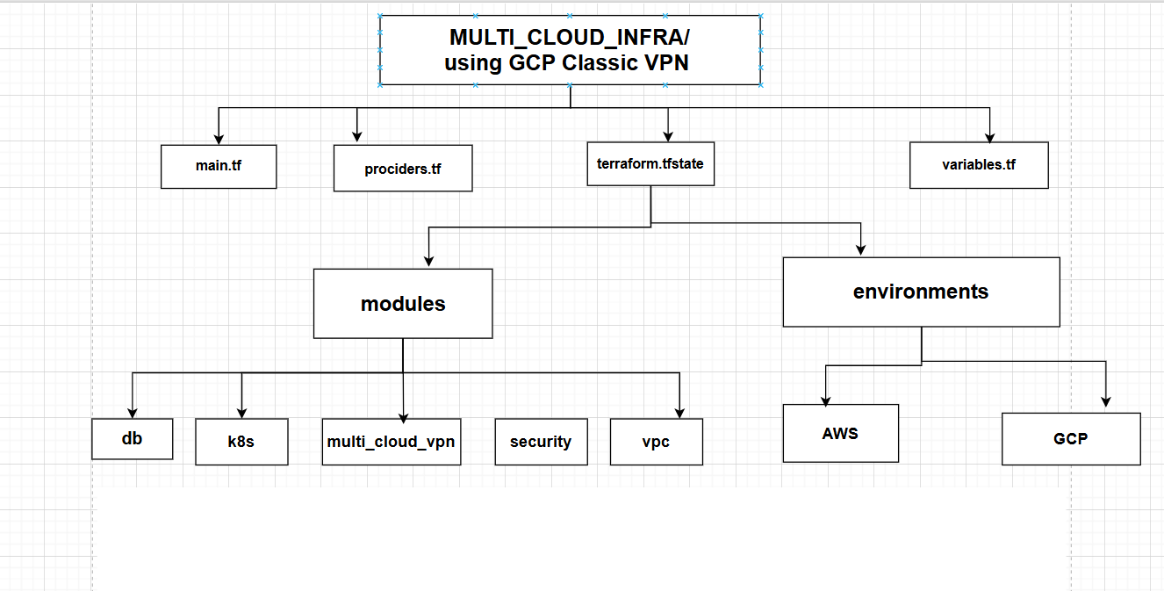

**Vpcs**

**Gcp cloud**

**Postgres**

**K8s**

**Key Management**

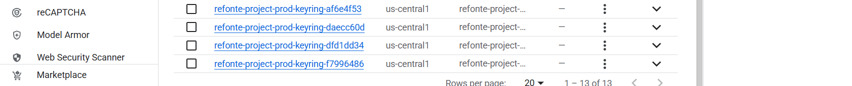

**Secret manger**

**VPN**

**AWS cloud**

**Postgres**

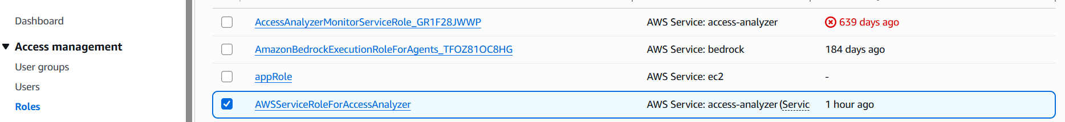

**K8s**

**Secret manager**

**KMS**

**VPN**

